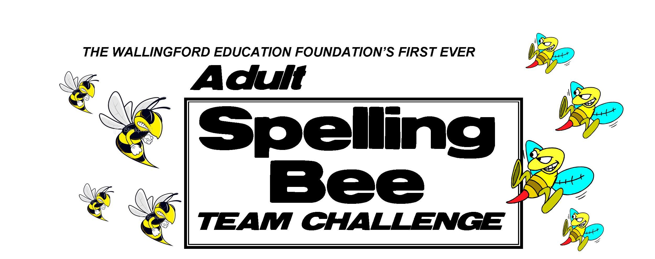

**BEEBEE RULES RULES**

1. Relax and have FUN! We encourage a PARTY atmosphere. Anyone not having fun will be asked to sit in the hive by themselves.

2. Each team will consist of three members, including a Captain who is the designated speller. You may register an alternate name in case of illness of a team member. Team members must be 16 years of age or older.

3. Up to 8 teams will be on stage at a time. This round of competition is referred to as a SWARM. The number of swarms will depend on the number of teams that register.

4. The announcer will pronounce the word, give the definition of the word, use it in a sentence and pronounce the word one additional time only. At that point the timer starts.

5. Team members on stage will have 25 seconds to collaborate on the spelling of the word. The Team Captain must CLEARLY PRINT the correct spelling of the word on the team whiteboard. Suggestion: The Team Captain should have good handwriting. (Example: If your team is a physician’s practice, probably best not to have the doctor as the captain.)

6. All teams must immediately stop writing when the timer sounds. Spellers will be eliminated if they continue to write, attempt to change the letters on the board, or attempt to erase the board before the judges give the okay.

7. Upon missing the spelling of one word in the preliminary swarms, a team is eliminated. As the swarm progresses, any team that misspells a word is eliminated. If all remaining teams misspell the same word, play continues. A swarm is over when all but one team is eliminated.

8. We will use the Merriam Webster's Collegiate Dictionary, 10th edition, 2002 copyright as the final say for any disputes.

9. Eliminated teams must return to the audience to cheer on the remaining competitors. Any team that buzzes out early will not receive their cool complimentary gifts. This would be a good time to enjoy a refreshment in the lobby.

10. The winner of each swarm shall compete in the Championship Swarm, and the same rules apply. The winning team receives the “Best of Hive” trophy.

11. The judges will make the final decision on all questions, including disputes, interpretation of rules, time, and any other issue. Honey Bee Court rulings are final. There will be no appeals.

12. Teams are expected to arrive at Moran Middle School, 141 Hope Hill Rd., Wallingford CT at 6:00pm on the day of the event for registration and review of rules and procedures.